Durham County Ladies’ Golf Association - Junior Competitions 2021
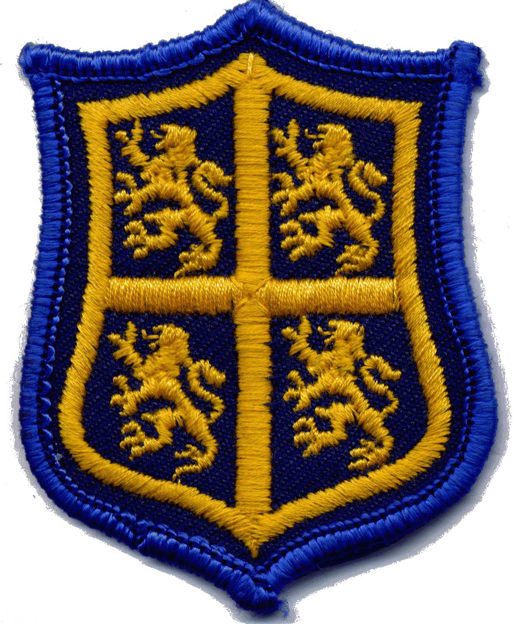

Saturday 10th April – Appleby Bowl – South Shields GC – 1st Tee 12 noon

18 hole strokeplay and 18 hole stableford competitions Entry fee £5
CLOSING DATE 3rd April
……………………………………………………………………………………………………………………………………………………………………
Entry Form

Name: ……………………………………………………………………………………………………………………………………
Address: ………………………………………………………………………………………………………………………………

I enclose a cheque for £5 Payable to Durham County Junior Girls’ Fund
Bank transfer: Account no: 51521307 Sort Code: 05-09-21 (Competion & name)

Telephone: ……………………………………….. Emergency contact no: ……………………………………………
Email: …………………………………………………………………………………………………………………………………….
D.O.B ………………………… Handicap ……………………….. Club ……………………………………………………..
I agree to my daughter taking part in the Appleby Bowl
Parent’s signature: ……………………………………………………………………………………………………………….

Entries should be sent to: Jackie Heaton (Junior Competition Secretary)
21, Elton Grove, Darlington, DL38HP
Tel: 07772920848
Email: Jackieheaton1812@aol.com

